Assignment Name & Number
1A) Intuitive Selection Exercise-
Assigned- March 11, 2022- Due April 9.
Buy Your Essence-
Create A Dosage Bottle.
Take this Flower Essence for 28 days.
Keep a Journal, highlighting your experience.
1B) Provide Verbal feedback in class, on how visual selection worked for you during class. Assigned March 11, 2022. Due April 8.
2A) Interview a Fellow Student Using the Kramer Technique.
Choose a partner. Assigned March 13, 2022- Due May 13.
Use page 4 of the outline; Assignment # 2 Interview # 1- Kramer/Bach Interview to do write up.
Write Up the Interview.
2B) Get Interviewed by Your Partner.
Take this essence for 28 days.
Keep notes on how this experience goes.
Send a summary of your own journey with these essences and your client interview to Laurie selfheal@telusplanet.net Assigned April 8- Due May 13
3A) Follow Up to Student Interview from Kramer technique.
Conduct about April 8 – Due June 10.
3B) 2nd Student Interview-
Choose a different partner for this assignment.
Conduct an interview and determine the essence selections. Do a write up choosing F.E.S. and Healing Herb brand essences. The blend you create may consist of more than 1 essence, less than 6. Follow Forms 3A & 3B for these assignments.
Interview assigned for May 2022 - Due July 2022.
4A) Interview A Client- Conduct after May 13, 2022-Due July 2022.
Use your Interview Form 3B- (Same as for 3B student interview).
5) Botanical Exercise
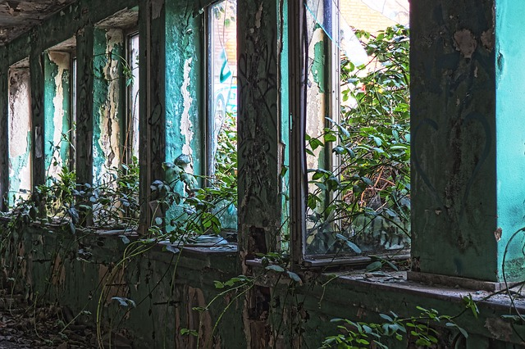
(To Be Presented in Class the last day of Flower Essence class, May 15).
Use the 12 Windows of Plant Perception Handout to plan your 15 minutes, or so, talk. http://www.flowersociety.org/twelve.htm
You will not need to hand your talk in, but rather guide the class through your perceptions. You may deviate from the form and get creative, but also cover the 12 windows thoroughly.
Start after the first weekend of class, while taking the single essence from your visual selection technique.
Details for each assignment can be found in chapter 13. You will be responsible to look up what is required and email or hand in each assignment to Laurie selfheal@telusplanet.net on the due date listed. Botanical Exercise #5 is an in-class presentation and does not need to be handed in.

