Goddess Storytelling Assignment
Due November 12, 2021
We will listen to and enjoy your presentations for this whole class. If there is extra time, we will delve into The Healing the Goddess Oracle Cards.

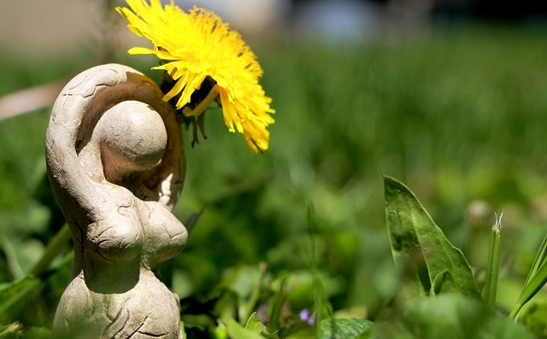
Diploma Students.
Research and prepare a 20-30-minute myth or story about the Goddess of your choice.
Choose a goddess from any culture that you feel drawn to but finding a Goddess who originates from your own cultural heritage can be especially empowering.
You will present in a circle, story-telling style on Nov. 12. Take adequate time to research what she represented, her myths and stories and why she was important to the culture. Also let us know why she is important to you, and how she might affect your life.
You can also sing her songs, dance her dance or share a ritual.
Be sure to dress up in attire suitable for her.
If you are doing your presentation on Zoom we will record. Or you may prepare your video presentation ahead of time and play it for us and submit it online for your part of the presentation.
Have fun and get to know your goddess!

